Firefighters have higher heart attack risk 'because of heat'

3 April 2017 - From the section Health www.bbc.com/news/health

Given to you at FDIC – April 2017 by Polar Breeze, Ben Kugler, President 727-480-9940, Ben@PolarBreeze.net, www.PolarBreeze.net, 877-474-2841
These are external links and will open in a new window
Share this with Facebook

Share this with Twitter

Share this with Messenger

Share this with Email
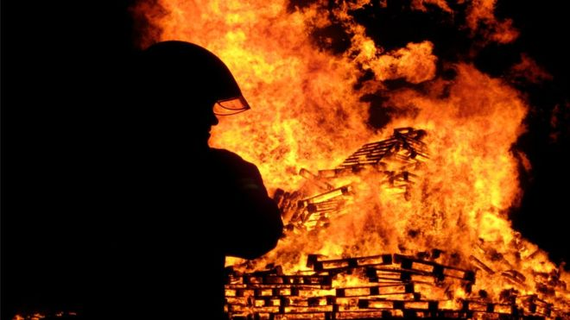Image copyrightGETTY IMAGES
Working in high temperatures increases the risk of suffering a heart attack, researchers have said.
The study may explain why heart disease is the leading cause of death among on-duty firefighters, the researchers from the University of Edinburgh said.
Firefighter Simon McNally, who was physically fit, had a heart attack while at work, at the age of 36.
"The doctor said if I'd gone home instead of coming to hospital I probably wouldn't have woken up."
He had been working as an instructor in Essex for three years where he set fires inside a shipping container three or four times a day, and was exposed to temperatures of 600-1,000C.
He was writing a report at his desk when he began to feel unwell.
"I felt a bit uncomfortable, I felt a bit sick. My left arm went numb and I looked at my nails and they'd gone blue and looked really strange and I thought - well, this isn't right. And then I started to be conscious of chest pains."
As their site was remote, he decided to drive to Chelmsford hospital where he was told he was having a heart attack.
"It did come as a bit of a shock. You're in denial as you're a relatively young, fit person so you think this shouldn't be happening to me. You want to get to the hospital for them to tell you that it's not a heart attack, that you've got acid reflux or something like that."
A marathon runner and triathlete, he was transferred to a London hospital after a week where a consultant told him he had a clot in one of his arteries.
He did have one slightly narrow coronary artery, but that shouldn't have caused any trouble.
"The consultant said there was a possibility that [the clot] was because my blood had thickened up because of the temperatures I'd been working in."

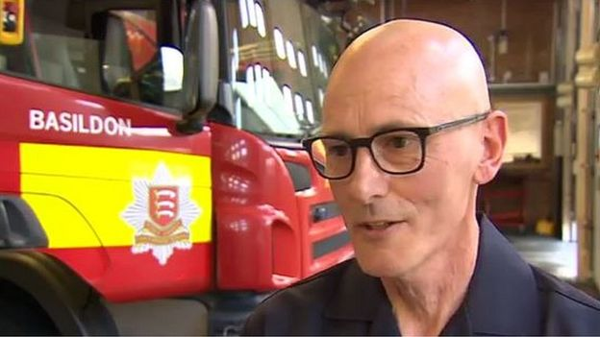Image captionFirefighter Simon McNally was 36 when he had a heart attack at work

Sticky blood
The research, funded by the British Heart Foundation (BHF), is published in the journal Circulation.
Nineteen non-smoking, healthy firefighters were randomly selected from the Scottish Fire and Rescue Service to take part in the study.
They took part in exercises, including an attempted mock rescue from a two-storey structure, which exposed them to extremely high temperatures, while wearing heart monitors.
They found their core body temperatures remained high for three to four hours following exposure to the fire.
They also found their blood became stickier and was about 66% more likely to form potentially harmful clots. Their blood vessels also failed to relax in response to medication.
The research team believe that the increase in clotting was caused by a combination of fluid loss due to sweating and an inflammatory response to the fire heat, which resulted in the blood becoming more concentrated and so more likely to clot.
The researchers also found that the exposure to fire caused minor injury to the heart muscles.
Prof Nick Mills, BHF senior clinical research fellow at the University of Edinburgh, who led the research, said: "Studies from the USA have shown that nearly half of all firefighters who die on duty are killed by heart disease.
"Our study has shown a direct link between the heat and physical activity levels encountered by firefighters during the course of their duties and their risk of suffering a heart attack.
"However, we've also found that there are simple measures, such as staying well hydrated, that firefighters can take to reduce this risk."

Warning signs
The Fire Brigades Union has called the findings "very disturbing".
Dave Green, a national officer with the Fire Brigades Union, said: "Although we have known about the increased risks of firefighters having heart attacks on duty or while training for some time, clearly fire service employers now need to urgently start to deal with this issue by ensuring firefighters don't suffer from dehydration or increased core body temperature from working in extreme temperatures for extended periods of time.
"Unfortunately however, cuts to the fire and rescue service mean that finding fresh crews to relieve firefighters who have already worked too long in heat isn't always possible."
Dr. Mike Knapton, BHF associate medical director, said: "It's essential that firefighters are aware of this risk and take simple steps such as taking time to cool down and rehydrate after tackling a blaze.
"It's also important for them to be aware of the early warning signs of a heart attack so that, if the worst should happen, they can receive medical attention as soon as possible.
"Most of us will never experience the scorching heat of a blazing inferno, but it's still good general health advice to drink plenty of fluid and take breaks if you're working up a sweat in high temperatures."

Fitness test
Simon McNally was off work for four months and when he went back he was not allowed to go back to hot fire training.
He is still a firefighter and says there is much more awareness now that those working in high temperatures should be drinking plenty of fluids.
But he fears there may be other firefighters who are unaware that they may be vulnerable.
"We have a fitness test every year and a check-up every three years but no-one knows the actual size and make up of their own heart."
Ann Millington, from the National Fire Chiefs Council (formerly Chief Fire Officers Association), said the organisation was "grateful to the Heart Foundation for this research".
"The health and safety of our firefighters is one of our paramount concerns and we will seriously consider the findings and work on ways to mitigate potential harm," she said.

End of Document

